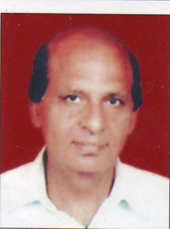
Dr. N. K. Rai

- Dr. N.K. Rai, An PG Psychology, from Delhi University D.Phil (Psy), PGDEVG, PGDHRM CTD, University of Manchester (UK) is a renowned Behavioural Scientist.
- He is a certified trainer from IDPM, Manchester Univ. (U.K.).
- Dr. Rai has more than 35 yrs of exp. of imparting training and education. He has trained large number of officers including IAS officers, managers and executives in Government, private and public sectors.
- He has worked in various senior positions in Govt. & Private sector. He has been Psychologist in NIVH, Joint Director – Behavioural training in the Institute of Secretariat training and management and Institute of Human Behaviour & Allied Science Govt of Delhi.
- He has also been on Professorial assignments with reputed B schools and universities.
- Training over a hundred clients - encompassing Educational societies/institutions/Govt and Pvt sector units - speaks a volume of his popularity as an accomplished and suave trainer.

